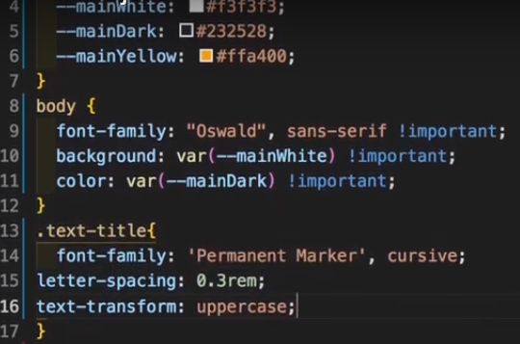

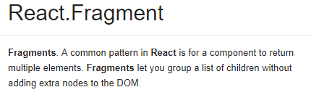

npm init –y

npx create-react-app my-app